**ASSIGNMENT:-4**

**EECE:-212**

**NAME: Shaharehar Rahaman Anik**

**Level: 2**

**ID No: 201916058**

**Here are some mathematical problem are solved by MATLAB 2020a.according to the questions. The answers are given bellow:**

1. **For a system, following values of x and corresponding values of y are given: (1,1),(2,28),(3,64),(4,43),(5,70),(6,95),(7,127),(8,149) . Find the value of y when x=2.8 and x=7.7 using Newton's Forward and Backward Difference Interpolation Formula in Matlab.**

**Solution:**

Here wanted to about the value of y when x=2.8 & x=7.7 using Newton’s Forward and Backward Difference Interpolation Formula in Matlab.

Now using,

**Forward method for x=2.8.**

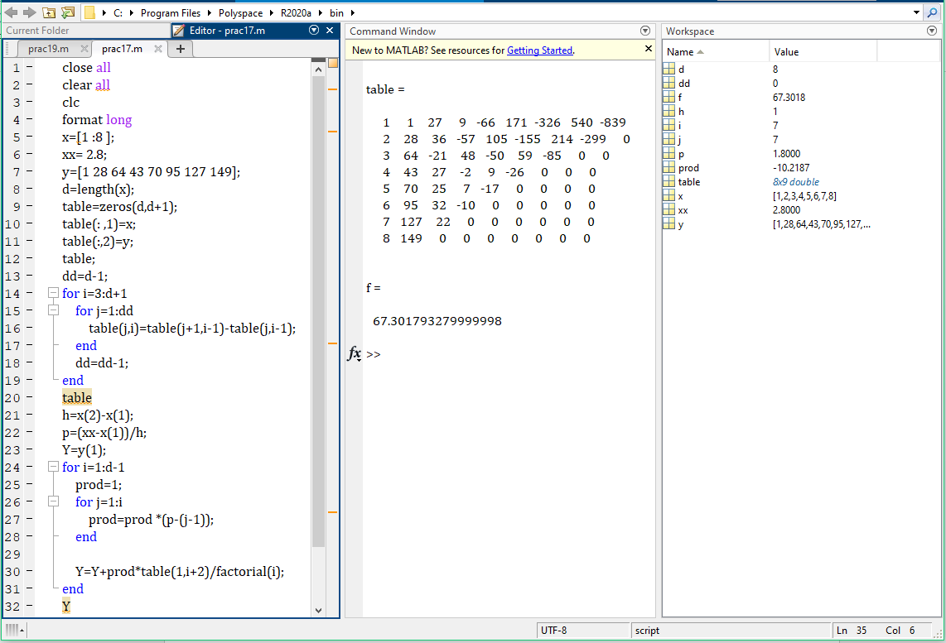

**Backward method for x=7.7:**

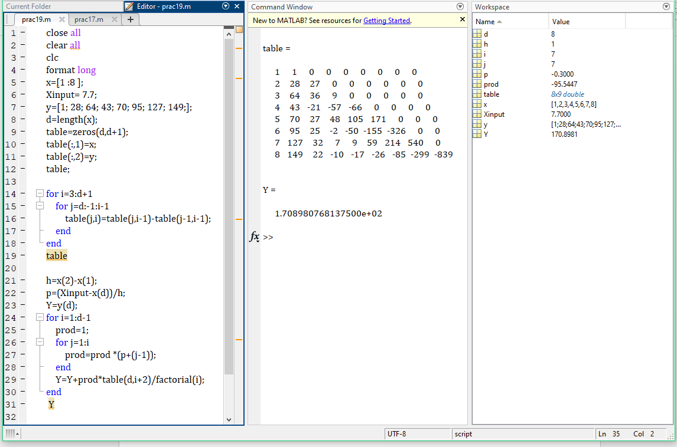

**The value,**

**Y=** **67.301793279999998; [when X=2.8]**

**Y= 1.708980768137500e+02; [when x=7.7]**

1. **Solve the above problem by hand calculation.**

**Solution:**

Here have to write down the hand calculation of the following function equation. First its done by **newton forward method**. When **x=2.8.**

**So the equation for newton forward method is:**

****Where**,** h=difference between two successive values of x.

$p=\frac{x-x0}{h}=1.8000000000$

The values of,, ….  Can be found from the following forward difference Table (Table-1).

1 1 27 9 -66 171 -326 540 -839

2 28 36 -57 105 -155 214 -299 0

3 64 -21 48 -50 59 -85 0 0

4 43 27 -2 9 -26 0 0 0

5 70 25 7 -17 0 0 0 0

6 95 32 -10 0 0 0 0 0

7 127 22 0 0 0 0 0 0

8 149 0 0 0 0 0 0 0

 **And so on……**

**The hand calculation is:**

$$y=1+ 1.800000*27+\frac{ 1.800*\left( 1.800-1\right)*9}{2!}+\frac{ 1.800*\left( 1.800-1\right)\left( 1.800-2\right)*\left(-66\right)}{3!}+\frac{ 1.800*\left( 1.800-1\right)\left( 1.800-2\right)\left( 1.800-3\right)*\left(171\right)}{4!}+\frac{ 1.800*\left( 1.800-1\right)\left( 1.800-2\right)\left( 1.800-3\right)\left( 1.800-4\right)*\left(-326\right)}{5!}+\frac{ 1.800*\left( 1.800-1\right)\left( 1.800-2\right)\left( 1.800-3\right)\left( 1.800-4\right)\left( 1.800-5\right)*\left(540\right)}{6!}+\frac{ 1.800*\left( 1.800-1\right)\left( 1.800-2\right)\left( 1.800-3\right)\left( 1.800-4\right)\left( 1.800-5\right)\left( 1.800-6\right)*(-839)}{7!}$$

**= 67.301793279999998**

**(Answer.)**

**Now for X=7.7;**

It’s done with **newton backward** method**.**

**So the equation for newton backward method is:**



Where,, h=difference between two successive values of x.

$p=\frac{x-x0}{h}=-0.300000$

Values of,, ….  Can be found from the following backward difference Table (Table-2).

1 1 0 0 0 0 0 0 0

2 28 27 0 0 0 0 0 0

3 64 36 9 0 0 0 0 0

4 43 -21 -57 -66 0 0 0 0

5 70 27 48 105 171 0 0 0

6 95 25 -2 -50 -155 -326 0 0

7 127 32 7 9 59 214 540 0

8 149 22 -10 -17 -26 -85 -299 -839

∇y1=y1-y0; ∇y2= y2-y1; ∇2y2=∇y2-∇y1; ∇3y3=∇2y3-∇2y2 and so on……………

**The hand calculation is:**

$$y=1+ -0.300000*22+\frac{ -0.300*\left( -0.300+1\right)*-10}{2!}+\frac{ -0.300*\left( -0.300+1\right)\left( -0.300+2\right)*\left(-17\right)}{3!}+\frac{ -0.300*\left( -0.300+1\right)\left( -0.300+2\right)\left( -0.300+3\right)*\left(-26\right)}{4!}+\frac{ -0.300*\left( -0.300+1\right)\left( -0.300+2\right)\left( -0.300+3\right)\left( -0.300+4\right)*\left(-85\right)}{5!}+\frac{ -0.300*\left( -0.300+1\right)\left( -0.300+2\right)\left( -0.300+3\right)\left( -0.300+4\right)\left( -0.300+5\right)*\left(-299\right)}{6!}+\frac{ -0.300*\left( -0.300+1\right)\left( -0.300+2\right)\left( -0.300+3\right)\left( -0.300+4\right)\left( -0.300+5\right)\left( -0.300+6\right)*(-839)}{7!}$$

**=1.708980768137500e+02**

**(Answer.)**